FLAGSHIP CHINESE SECONDARY CURRICULUM
DEVELOPING CHINESE – Level 2
UNIT 3: Food and Restaurant

Assessment: Presentational Writing

_{Learning Targets}
I can write an invitation card with date, time and place.
I can write the name of Chinese dishes.
I can describe what dishes to bring to a party.

Scenario 1

You are planning a birthday party for a Chinese Exchange student from your school. You know that he/she feels homesick, and you want to make him/her to feel at home, so you invite your friends to celebrate his/her birthday and assign them to bring one of their favorite Chinese dishes to the party.

You want to include the following:
- A invitation card with date, time & place
- The name of the Chinese student
- The name of the Chinese dishes that will be served

Feel free to write anything else that you might find interesting or helpful.

Adapted from Jefferson County Public Schools, KY, 2011
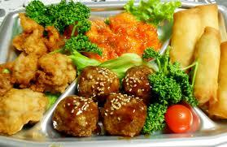

Planning/Outline

